Welcome To
Trinity Lutheran Church
Lutheran Church—Missouri Synod
A Stephen Ministry Congregation

1354 South Otsego Avenue
Gaylord, Michigan 49735
Church Phone: (989) 732-4816

Church Email: secretary@trinitygaylord.com
www.trinitygaylord.com

Office Hours: Monday through Friday 9am – 1pm

OUR PURPOSE
…is to LOVE GOD, LOVE OTHERS, AND SERVE THE WORLD by worshiping the Lord Jesus, bringing our members into Christ-like maturity, and equipping them through Word and Sacrament for their mission and ministry. We go heart to heart into the world with Jesus, sharing His love, caring for one another, praying, and bringing the lost into a relationship with Christ, by the working of the Holy Spirit.

October 9, 2022
Eighteenth Sunday after Pentecost
Preacher: Rev. Ken Bernthal

ABOUT OUR WORSHIP
We welcome all who gather here today! We are blessed to celebrate together the mercy, grace, and love we have from God through the death and resurrection of our Lord Jesus Christ.

Children: Families with children are very welcome here. Having children in church is important so they can begin to learn about their faith in Jesus, and it’s good for the whole congregation to see. Please feel comfortable keeping “squirmy” kids in the service. This is where they belong, too!

Pew Cards: Guests and Members, please fill out the Guest/Member card located on the back of the pew in front of you and pass it to the end of the aisle. If you forget you can put it in the offering plate on your way out.

If standing is difficult: Please feel free to remain seated during any portion of the service. Please let an Elder or Usher know if you need communion in your pew seat.

About our celebration of Holy Communion: We celebrate the Lord’s Supper in the confession and glad confidence that, as he says, our Lord gives into our mouths not only bread and wine but his very body and blood to eat and to drink for the forgiveness of sins and to strengthen our union with him and with one another. Our Lord invites to his table those who trust his words, repent of all sin, and set aside any refusal to forgive and love as he forgives and loves us, that they may show forth his death until he comes.

Because those who eat and drink our Lord’s body and blood contrary to that which is stated above do so to their great harm, and also because Holy Communion is a confession of the faith which is confessed at this altar. Anyone who is not yet instructed, in doubt, or who hold a confession differing from that of the Lutheran Church—Missouri Synod, and yet desire to receive the sacrament, are asked first to speak with Pastor. Those not communing are still invited to come forward for a blessing from Pastor, and you may indicate this by crossing your arms over your chest.
TTTTTT
GREETING

P Peace be with you.
C And also with you.
T ORDER OF SERVICE T
(The liturgy is from Divine Service Setting four LSB pg. 203ff)

BAPTISM OF JEFFERY LEVI TRAHIN

BLESSING OF THE QUILTS

OPENING HYNM
Blessed Jesus, at Your Word LSB 904 Stand on V.4
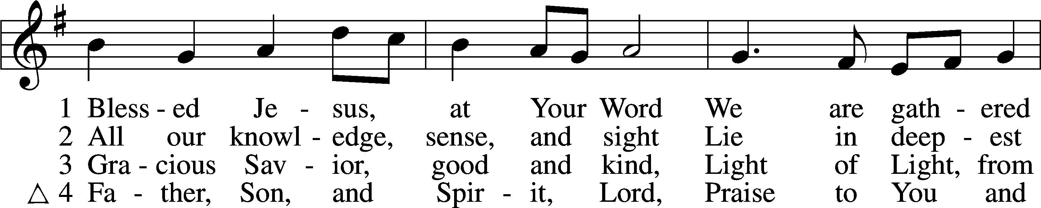
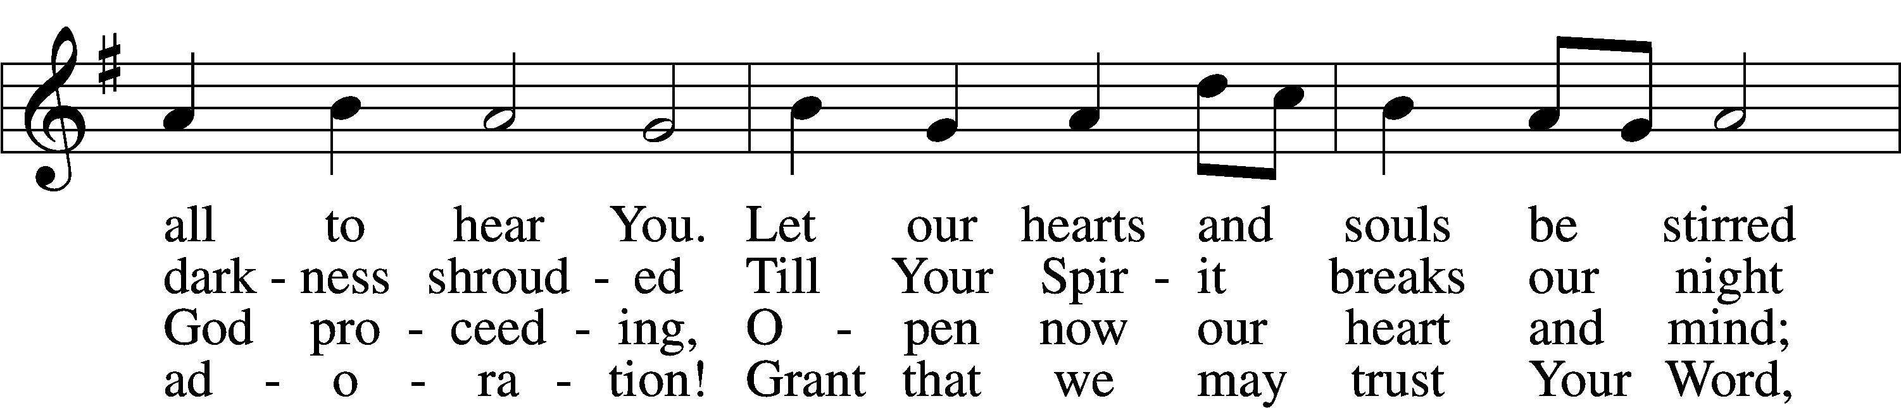
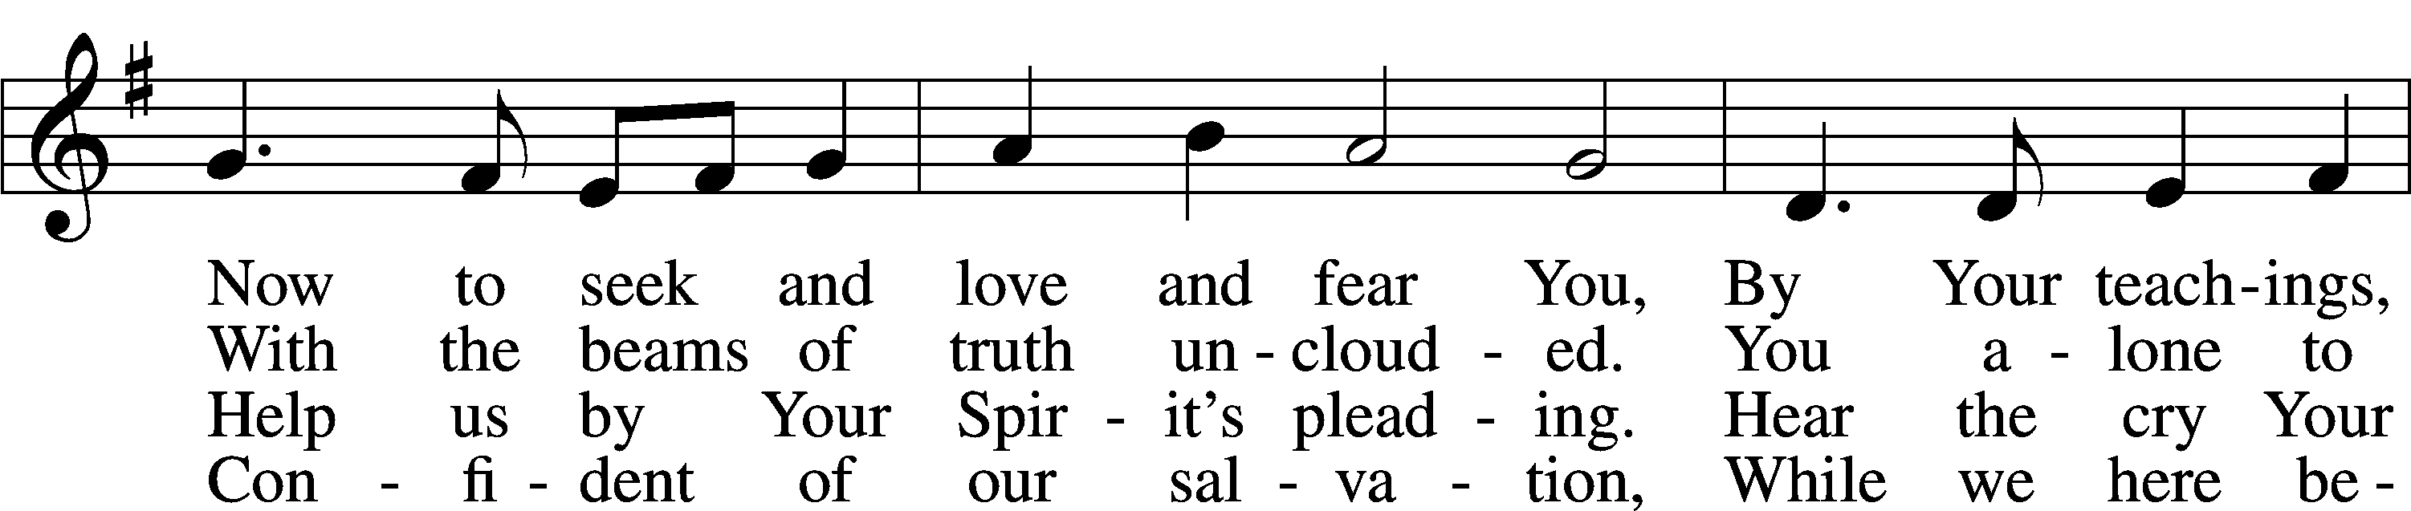
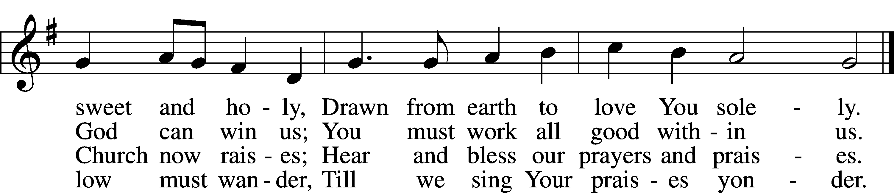

CONFESSION and ABSOLUTION
The sign of the cross may be made by all in remembrance of their Baptism.

P In the name of the Father and of the T Son and of the Holy Spirit.
C Amen.
P Our help is in the name of the Lord,
C who made heaven and earth.
P If You, O Lord, kept a record of sins, O Lord, who could stand?
C But with You there is forgiveness; therefore, You are feared.
P Since we are gathered to hear God’s Word, call upon Him in prayer and praise, and receive the body and blood of our Lord Jesus Christ in the fellowship of this altar, let us first consider our unworthiness and confess before God and one another that we have sinned in thought, word, and deed, and that we cannot free ourselves from our sinful condition. Together as His people let us take refuge in the infinite mercy of God, our heavenly Father, seeking His grace for the sake of Christ, and saying: God, be merciful to me, a sinner.
C Almighty God, have mercy upon us, forgive us our sins, and lead us to everlasting life. Amen.
P Almighty God in His mercy has given His Son to die for you and for His sake forgives you all your sins. As a called and ordained servant of Christ, and by His authority, I therefore forgive you all your sins in the name of the Father and of the T Son and of the Holy Spirit.
C Amen.

SERVICE OF THE WORD
KYRIE LSB 204
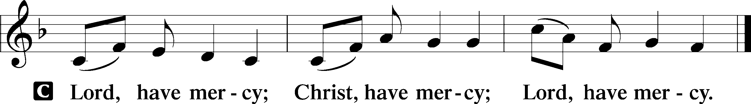

HYMN OF PRAISE
GLORIA IN EXCELSIS LSB 204
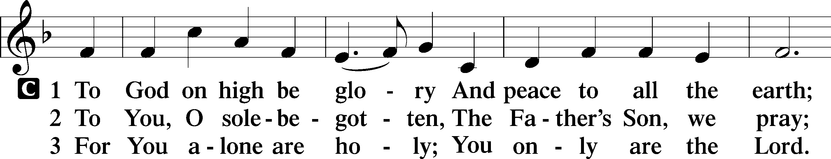
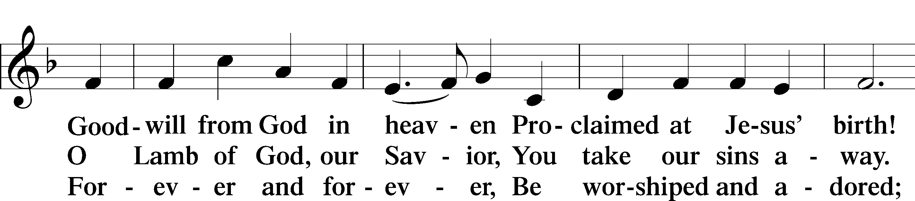
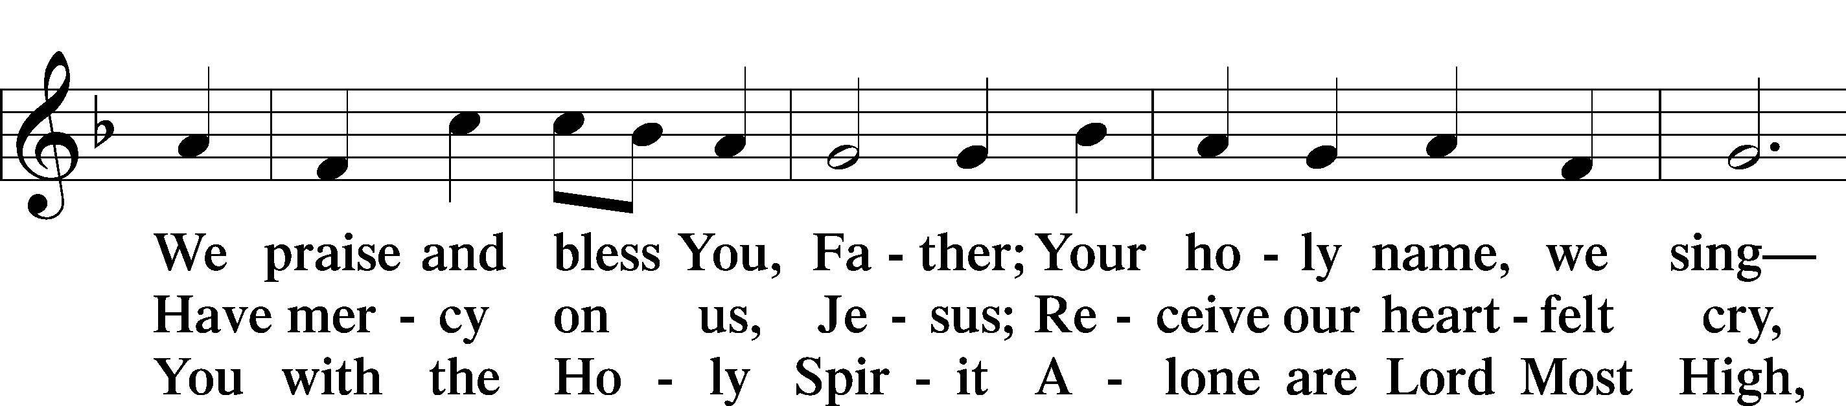
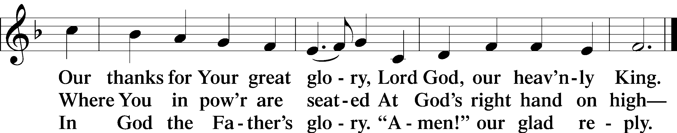

SALUTATION AND COLLECT OF THE DAY
P The Lord be with you.
C And also with you.

P Let us pray.
O God, our refuge and strength, the author of all godliness, by Your grace hear the prayers of Your Church. Grant that those things which we ask in faith we may receive through Your bountiful mercy; through Jesus Christ, Your Son, our Lord, who lives and reigns with You and the Holy Spirit, one God, now and forever.
C Amen.

Please be seated
OLD TESTAMENT Ruth 1:1–19a
¹In the days when the judges ruled there was a famine in the land, and a man of Bethlehem in Judah went to sojourn in the country of Moab, he and his wife and his two sons. ²The name of the man was Elimelech and the name of his wife Naomi, and the names of his two sons were Mahlon and Chilion. They were Ephrathites from Bethlehem in Judah. They went into the country of Moab and remained there. ³But Elimelech, the husband of Naomi, died, and she was left with her two sons. ⁴These took Moabite wives; the name of the one was Orpah and the name of the other Ruth. They lived there about ten years, ⁵and both Mahlon and Chilion died, so that the woman was left without her two sons and her husband.
⁶Then she arose with her daughters-in-law to return from the country of Moab, for she had heard in the fields of Moab that the Lord had visited his people and given them food. ⁷So she set out from the place where she was with her two daughters-in-law, and they went on the way to return to the land of Judah. ⁸But Naomi said to her two daughters-in-law, “Go, return each of you to her mother’s house. May the Lord deal kindly with you, as you have dealt with the dead and with me. ⁹The Lord grant that you may find rest, each of you in the house of her husband!” Then she kissed them, and they lifted up their voices and wept. ¹⁰And they said to her, “No, we will return with you to your people.” ¹¹But Naomi said, “Turn back, my daughters; why will you go with me? Have I yet sons in my womb that they may become your husbands? ¹²Turn back, my daughters; go your way, for I am too old to have a husband. If I should say I have hope, even if I should have a husband this night and should bear sons, ¹³would you therefore wait till they were grown? Would you therefore refrain from marrying? No, my daughters, for it is exceedingly bitter to me for your sake that the hand of the Lord has gone out against me.” ¹⁴Then they lifted up their voices and wept again. And Orpah kissed her mother-in-law, but Ruth clung to her.
¹⁵And she said, “See, your sister-in-law has gone back to her people and to her gods; return after your sister-in-law.” ¹⁶But Ruth said, “Do not urge me to leave you or to return from following you. For where you go I will go, and where you lodge I will lodge. Your people shall be my people, and your God my God. ¹⁷Where you die I will die, and there will I be buried. May the Lord do so to me and more also if anything but death parts me from you.” ¹⁸And when Naomi saw that she was determined to go with her, she said no more.
¹⁹So the two of them went on until they came to Bethlehem.
P This is the Word of the Lord.
C Thanks be to Go
EPISTLE 2 Timothy 2:1–13
¹You then, my child, be strengthened by the grace that is in Christ Jesus, ²and what you have heard from me in the presence of many witnesses entrust to faithful men who will be able to teach others also. ³Share in suffering as a good soldier of Christ Jesus. ⁴No soldier gets entangled in civilian pursuits, since his aim is to please the one who enlisted him. ⁵An athlete is not crowned unless he competes according to the rules. ⁶It is the hard-working farmer who ought to have the first share of the crops. ⁷Think over what I say, for the Lord will give you understanding in everything.
⁸Remember Jesus Christ, risen from the dead, the offspring of David, as preached in my gospel, ⁹for which I am suffering, bound with chains as a criminal. But the word of God is not bound! ¹⁰Therefore I endure everything for the sake of the elect, that they also may obtain the salvation that is in Christ Jesus with eternal glory. ¹¹The saying is trustworthy, for:
If we have died with him, we will also live with him;
¹²if we endure, we will also reign with him;
if we deny him, he also will deny us;
¹³if we are faithless, he remains faithful—
for he cannot deny himself.
P This is the Word of the Lord.
C Thanks be to God.
Please stand as able
ALLELUIA AND VERSE
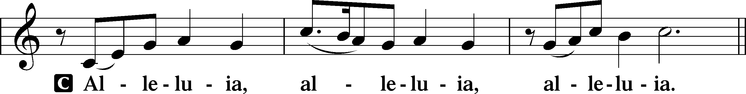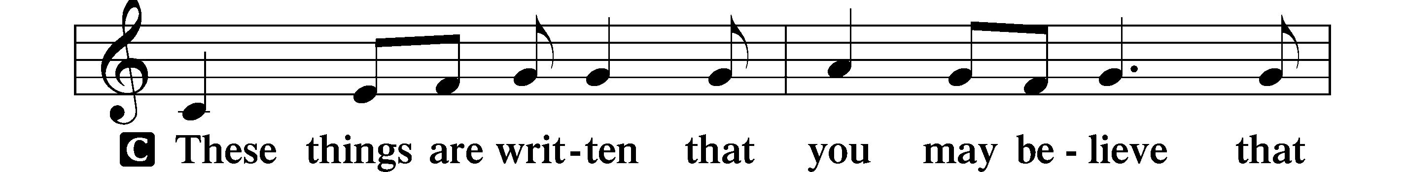
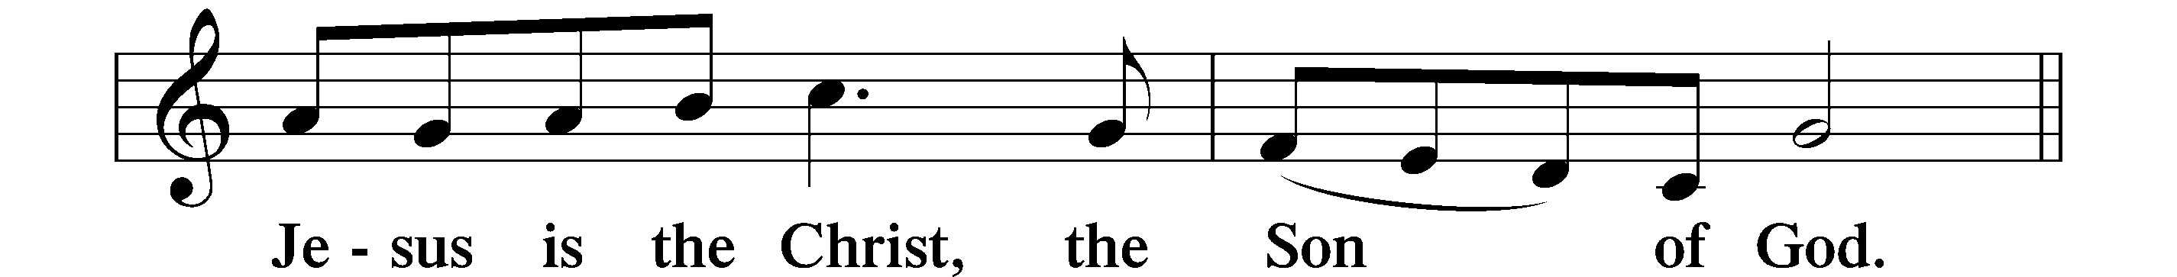
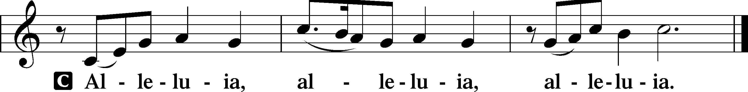
HOLY GOSPEL Luke 17:11–19
P The Holy Gospel according to St. Luke, the seventeenth chapter.
C Glory to You, O Lord.

¹¹On the way to Jerusalem [Jesus] was passing along between Samaria and Galilee. ¹²And as he entered a village, he was met by ten lepers, who stood at a distance ¹³and lifted up their voices, saying, “Jesus, Master, have mercy on us.” ¹⁴When he saw them he said to them, “Go and show yourselves to the priests.” And as they went they were cleansed. ¹⁵Then one of them, when he saw that he was healed, turned back, praising God with a loud voice; ¹⁶and he fell on his face at Jesus’ feet, giving him thanks. Now he was a Samaritan. ¹⁷Then Jesus answered, “Were not ten cleansed? Where are the nine? ¹⁸Was no one found to return and give praise to God except this foreigner?” ¹⁹And he said to him, “Rise and go your way; your faith has made you well.”

P This is the Gospel of the Lord.
C Praise to You, O Christ.

NICENE CREED
C I believe in one God,
the Father Almighty,
maker of heaven and earth
and of all things visible and invisible.
And in one Lord Jesus Christ,
the only-begotten Son of God,
begotten of His Father before all worlds,
God of God, Light of Light,
very God of very God,
begotten, not made,
being of one substance with the Father,
by whom all things were made;
who for us men and for our salvation came down from heaven
and was incarnate by the Holy Spirit of the virgin Mary
and was made man;
and was crucified also for us under Pontius Pilate.
He suffered and was buried.
And the third day He rose again according to the Scriptures
and ascended into heaven
and sits at the right hand of the Father.
And He will come again with glory to judge both the living and the dead,
whose kingdom will have no end.
And I believe in the Holy Spirit,
the Lord and giver of life,
who proceeds from the Father and the Son,
who with the Father and the Son together is worshiped and glorified,
who spoke by the prophets.
And I believe in one holy Christian and apostolic Church,
I acknowledge one Baptism for the remission of sins,
and I look for the resurrection of the dead
and the life T of the world to come. Amen.

Please be seated

ALL GOD’S CHILDREN – TALK

SERMON HYMN
Blest Be the Tie That Binds LSB 649
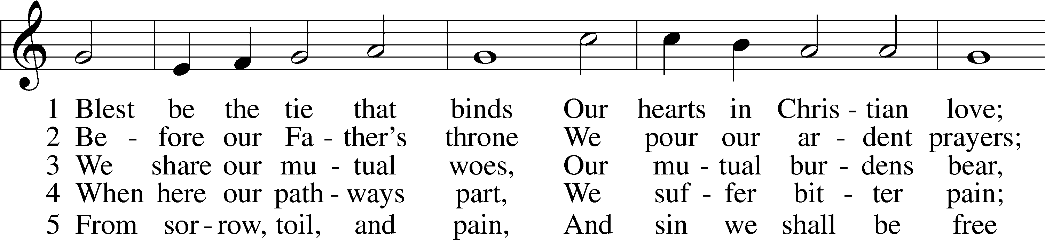
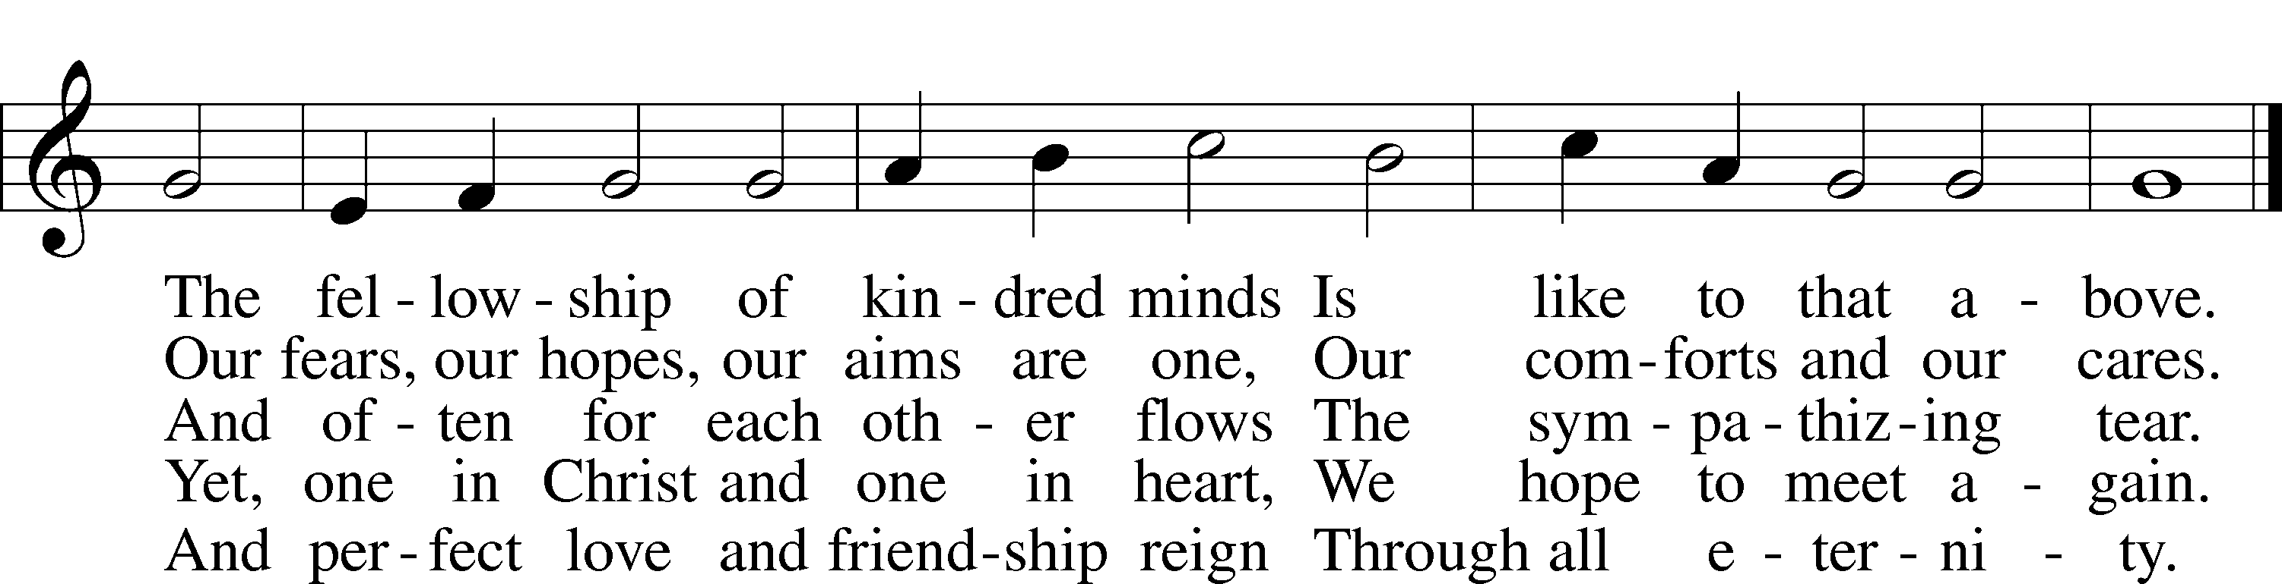

SERMON

Please stand as able

PRAYER of the CHURCH
After each Segment:
P Lord, in Your Mercy,
C Hear our Prayer.
After Final Segment:
P Hear us as we pray in His name and as He has taught us:
LORD’S PRAYER
C Our Father who art in heaven,
hallowed be Thy name,
Thy kingdom come,
Thy will be done on earth
as it is in heaven;
give us this day our daily bread;
and forgive us our trespasses
as we forgive those
who trespass against us;
and lead us not into temptation,
but deliver us from evil.
For Thine is the kingdom
and the power and the glory
forever and ever. Amen.

T SERVICE of the SACRAMENT T

PREFACE LSB 208
P The Lord be with you.
C And also with you.
P Lift up your hearts.
C We lift them to the Lord.
P Let us give thanks to the Lord our God.
C It is right to give Him thanks and praise.
P It is truly good, right, and salutary that we should at all times and in all places give thanks to You, O Lord, holy Father, almighty and everlasting God, for the countless blessings You so freely bestow on us and all creation. Above all, we give thanks for Your boundless love shown to us when You sent Your only-begotten Son, Jesus Christ, into our flesh and laid on Him our sin, giving Him into death that we might not die eternally. Because He is now risen from the dead and lives and reigns to all eternity, all who believe in Him will overcome sin and death and will rise again to new life. Therefore with angels and archangels and with all the company of heaven we laud and magnify Your glorious name, evermore praising You and singing:

SANCTUS LSB 208
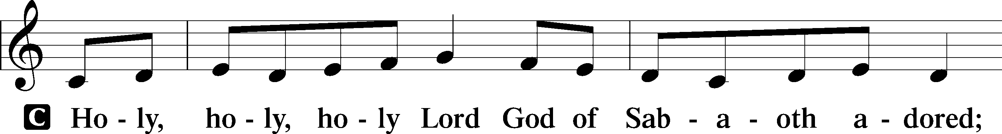
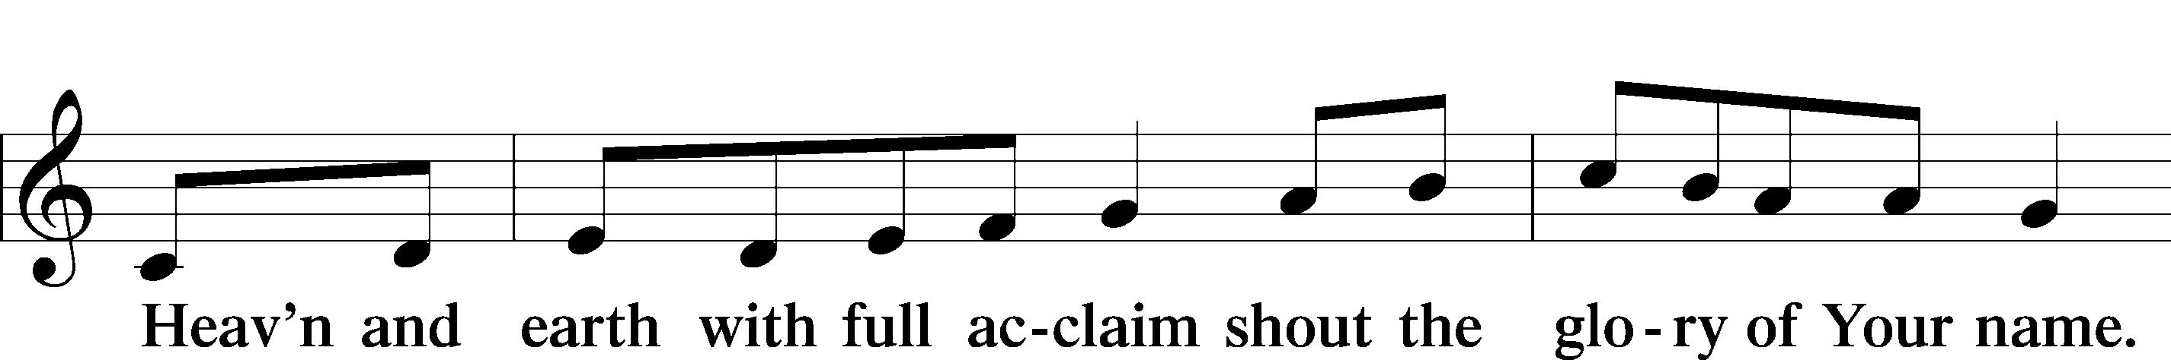
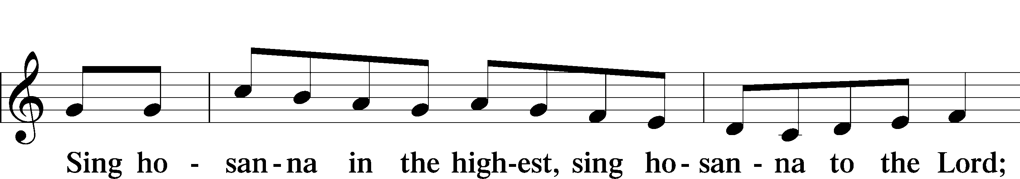
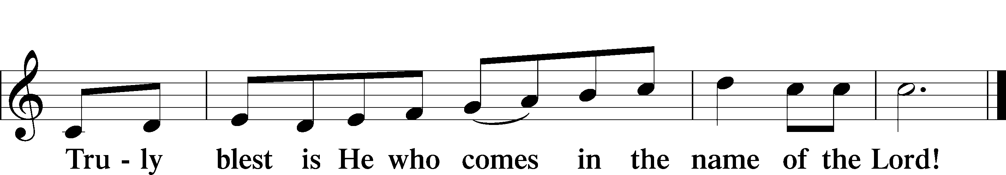
PRAYER OF THANKSGIVING
P Blessed are You, O Lord our God, king of all creation, for You have had mercy on us and given Your only-begotten Son that whoever believes in Him should not perish but have eternal life.
In Your righteous judgment You condemned the sin of Adam and Eve, who ate the forbidden fruit, and You justly barred them and all their children from the tree of life. Yet, in Your great mercy, You promised salvation by a second Adam, You Son,Jesus Christ, our Lord, and made His cross a life-giving tree for all who trust in Him.
We give You thanks for the redemption You have prepared for us through Jesus Christ. Grant us Your Holy Spirit that we may faithfully eat and drink of the fruits of His cross and receive the blessings of forgiveness, life, and salvation that come to us in His body and blood.
THE WORDS OF OUR LORD
P Our Lord Jesus Christ, on the night when He was betrayed, took bread, and when He had given thanks, He broke it and gave it to the disciples and said: “Take, eat; this is My T body, which is given for you. This do in remembrance of Me.”
In the same way also, He took the cup after supper, and when He had given thanks, He gave it to them, saying: “Drink of it, all of you; this cup is the New Testament in My T blood, which is shed for you for the forgiveness of sins. This do, as often as you drink it, in remembrance of Me.”

PAX DOMINI
P The peace of the Lord be with you always.
C Amen.
AGNUS DEI
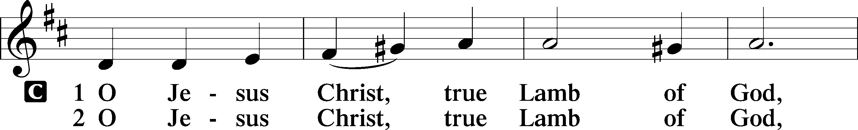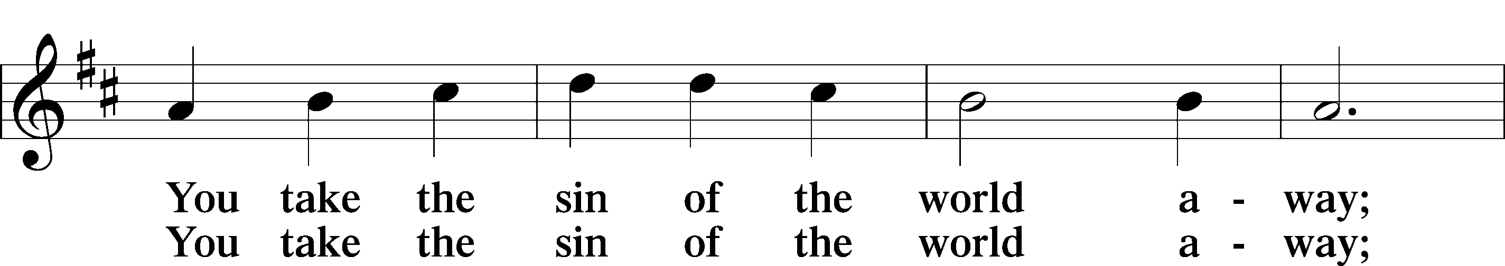
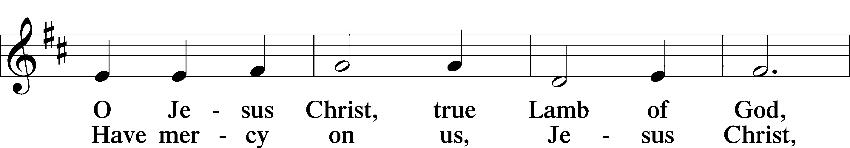
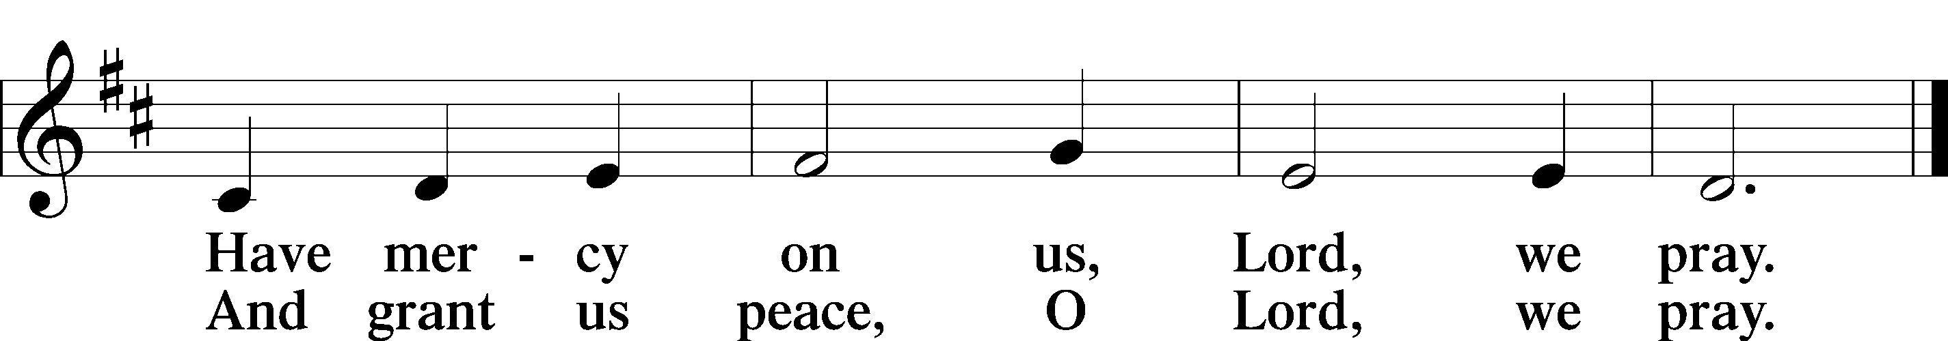

Please be seated

DISTRIBUTION
The pastor and those who assist him receive the body and blood of Christ first, then Communion will be served at the rail. Ushers will help direct you forward via the center aisle; please return to your seats via the side aisles. Gluten-free bread is available for those who need it, as is non-alcoholic grape juice. Simply request either when you come forward to receive Communion.

DISTRIBUTION HYMN
I Come, O Savior, to Thy Table L SB 618
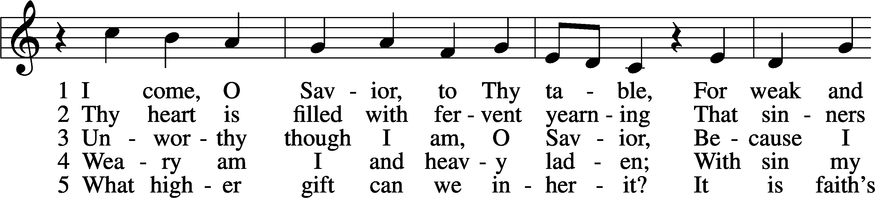
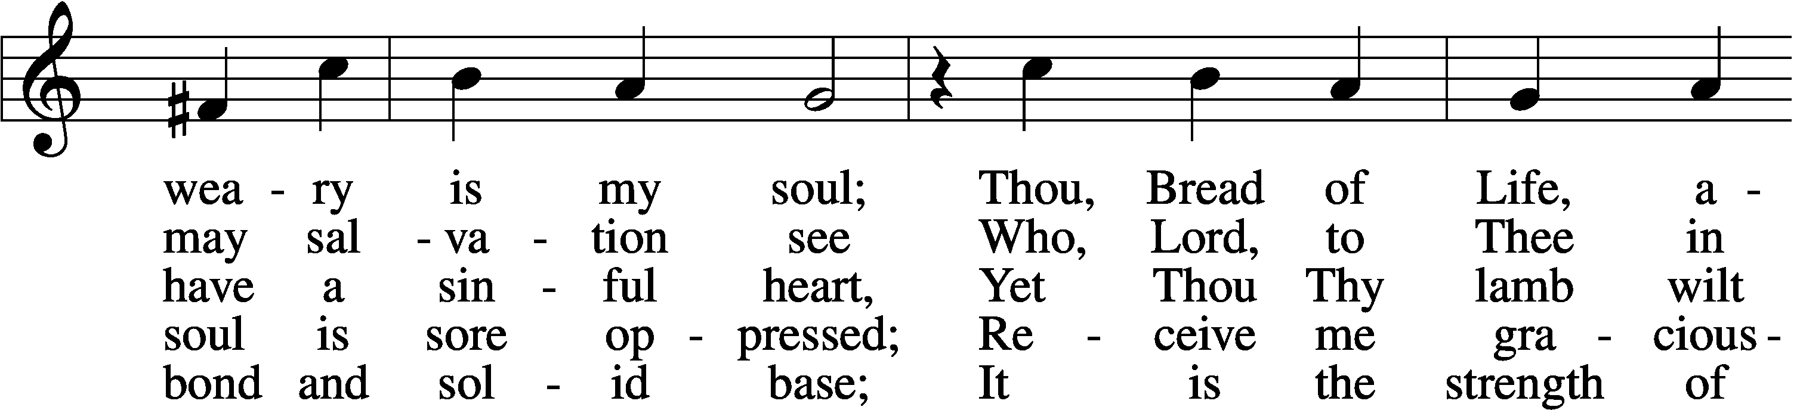
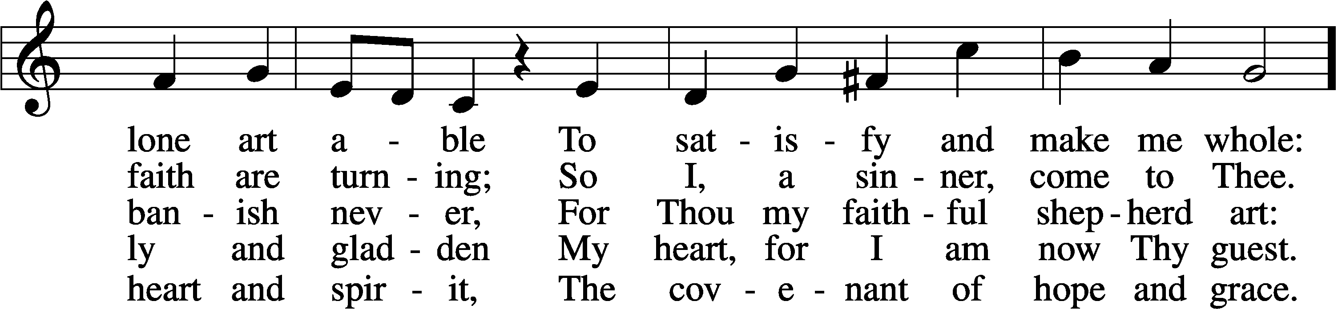
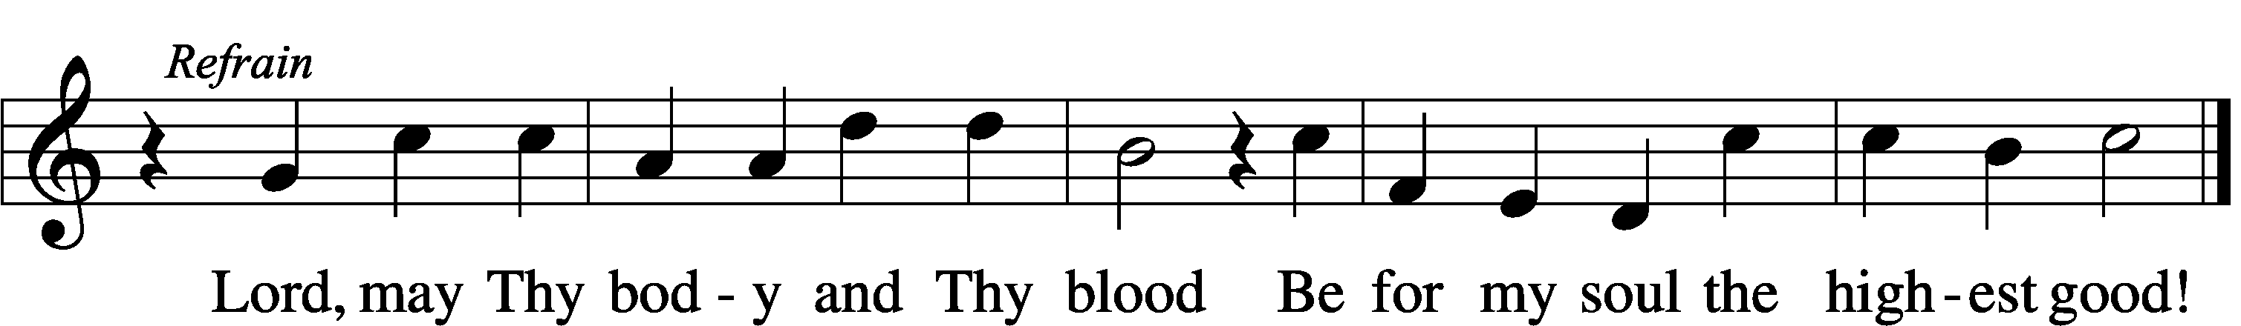

DISTRIBUTION HYMN
O Savior, Precious Savior LSB 527
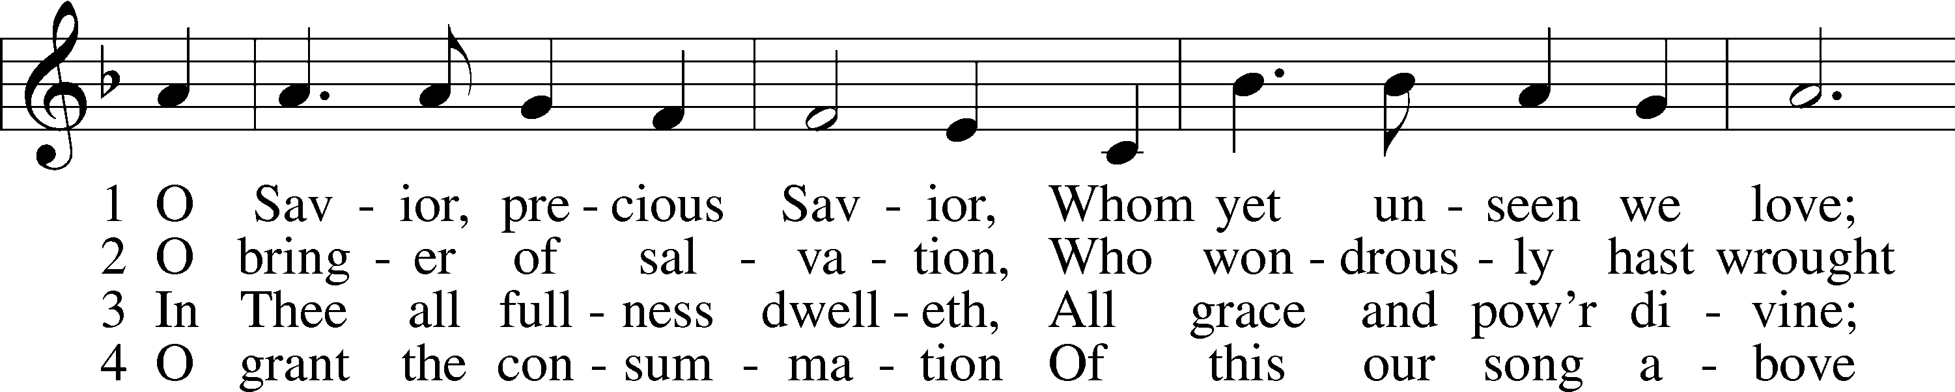
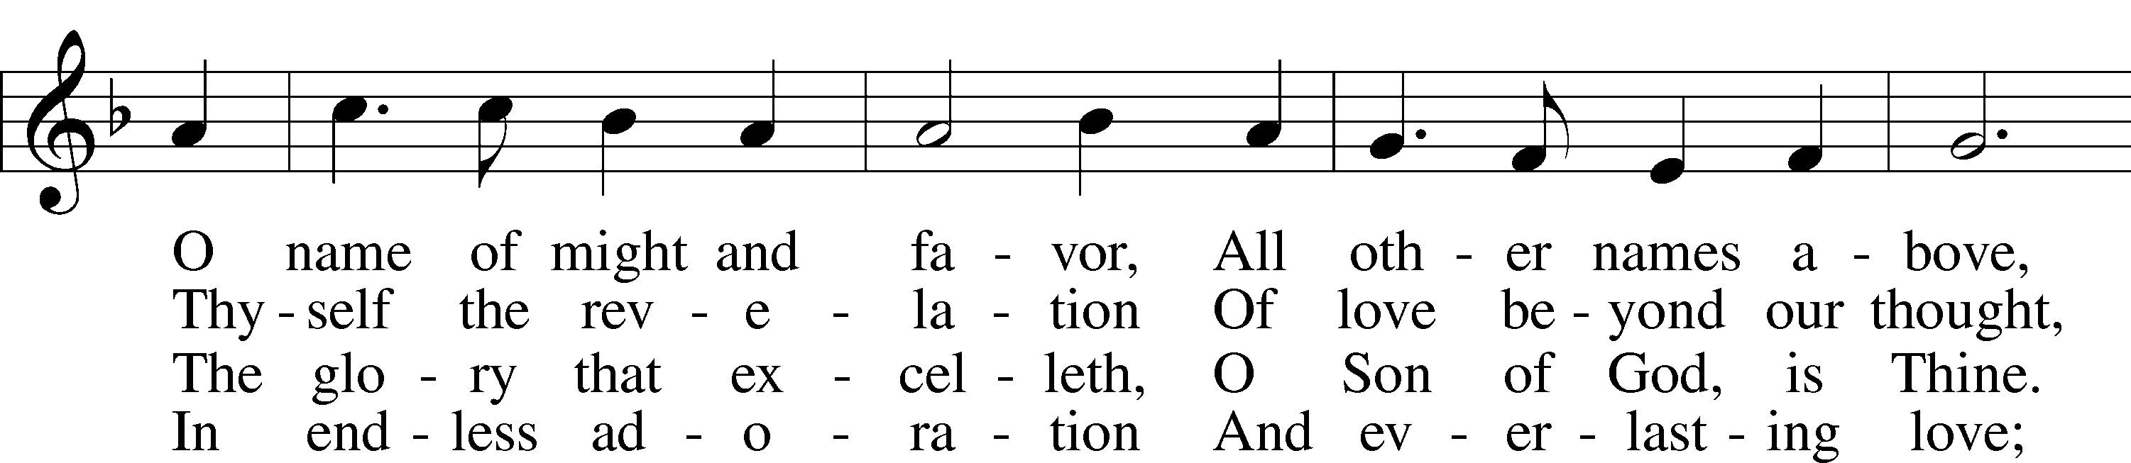
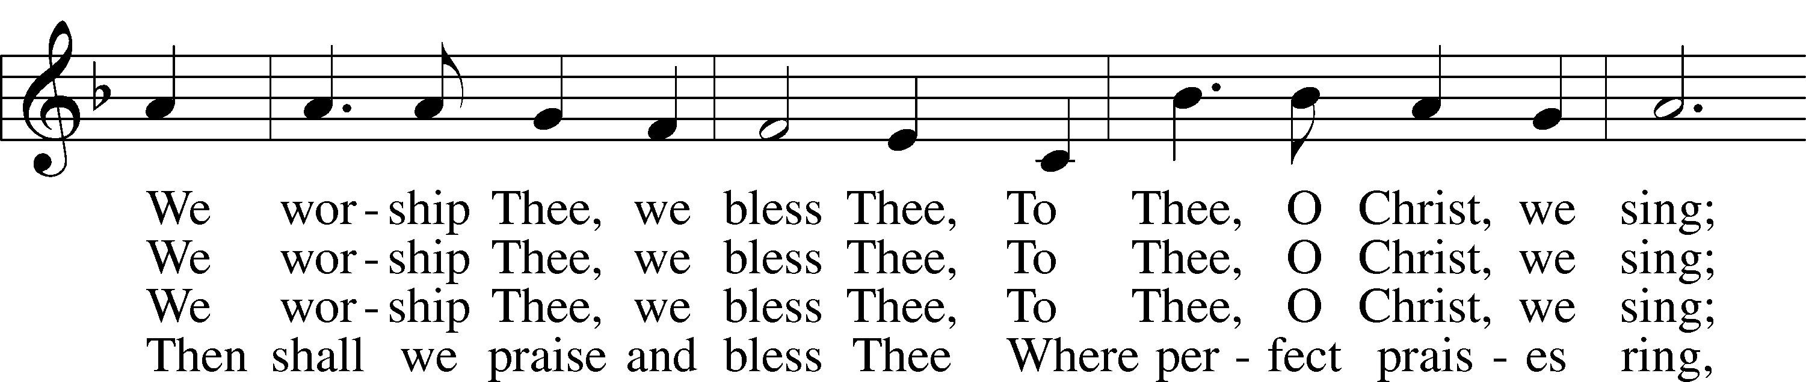
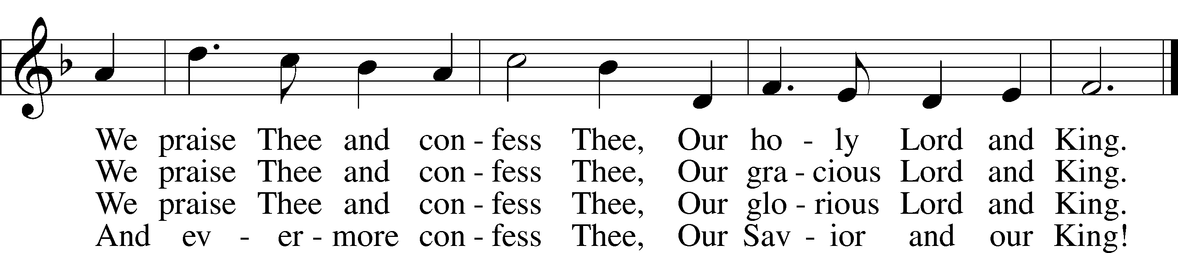

Please stand as able

NUNC DIMITTIS LSB 211
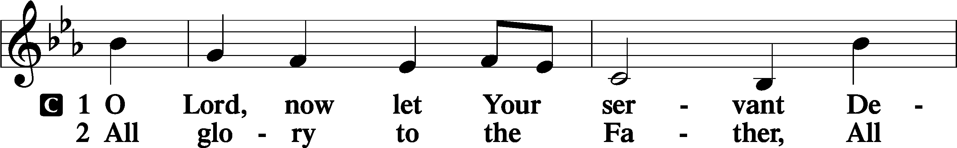
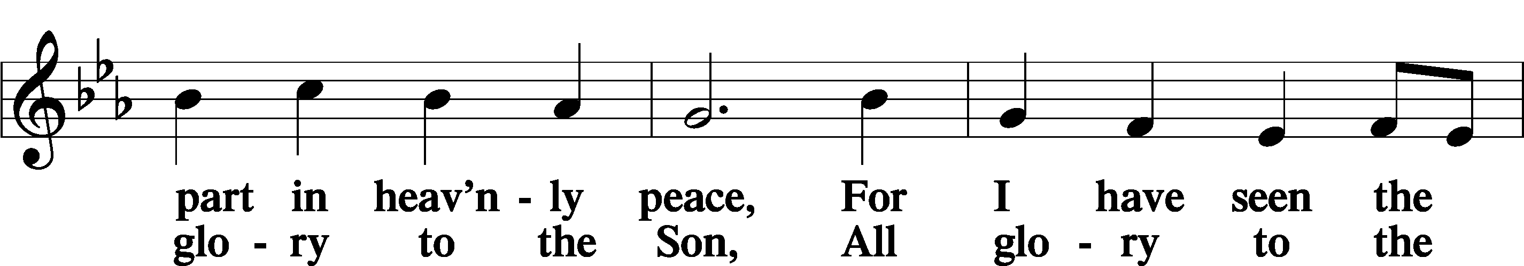
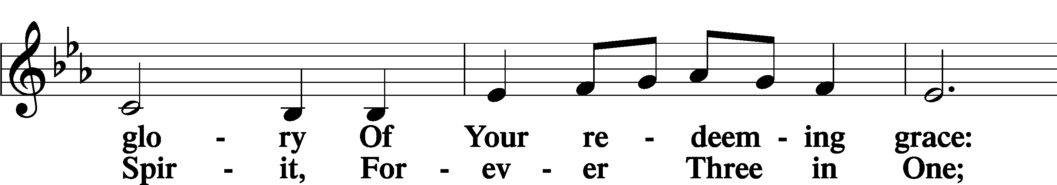
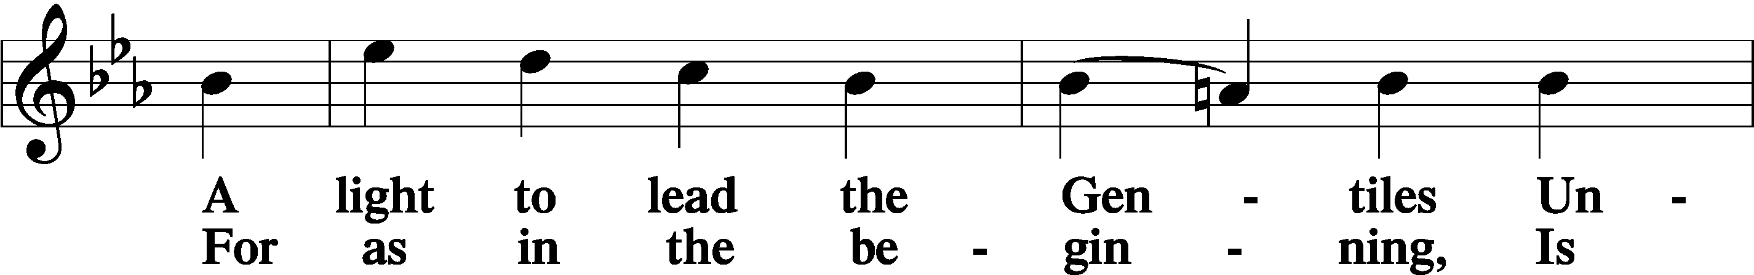
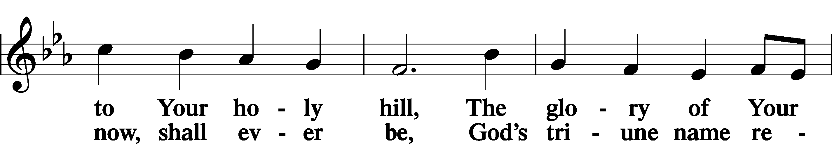
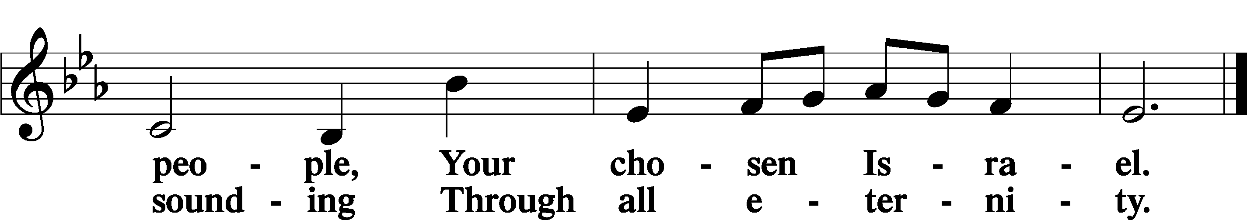

POST COMMUNION COLLECT
P Let us pray.
We give thanks to You, almighty God, that You have refreshed us through this salutary gift, and we implore You that of Your mercy You would strengthen us through the same in faith toward You and in fervent love toward one another; through Jesus Christ, Your Son, our Lord, who lives and reigns with You and the Holy Spirit, one God, now and forever.
C Amen.

BENEDICAMUS LSB 212
P Let us bless the Lord.
C Thanks be to God.
BENEDICTION
P The Lord bless you and keep you.
The Lord make His face shine on you and be gracious to you.
The Lord look upon you with favor and T give you peace.
C Amen.
Please be seated
CLOSING HYMN
Go, My Children, with My Blessing LSB 922
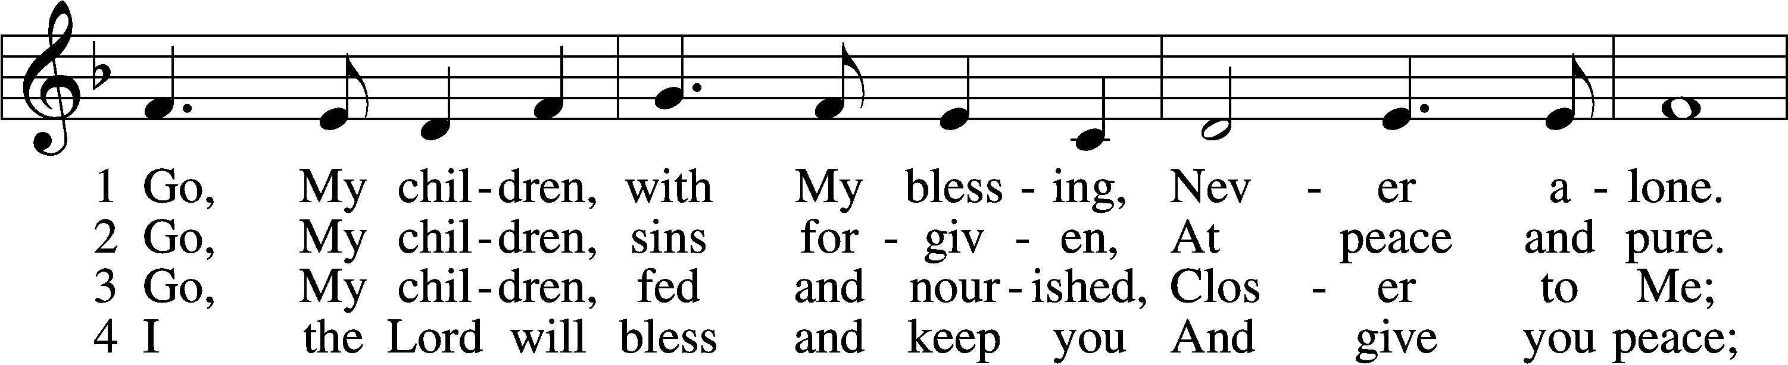
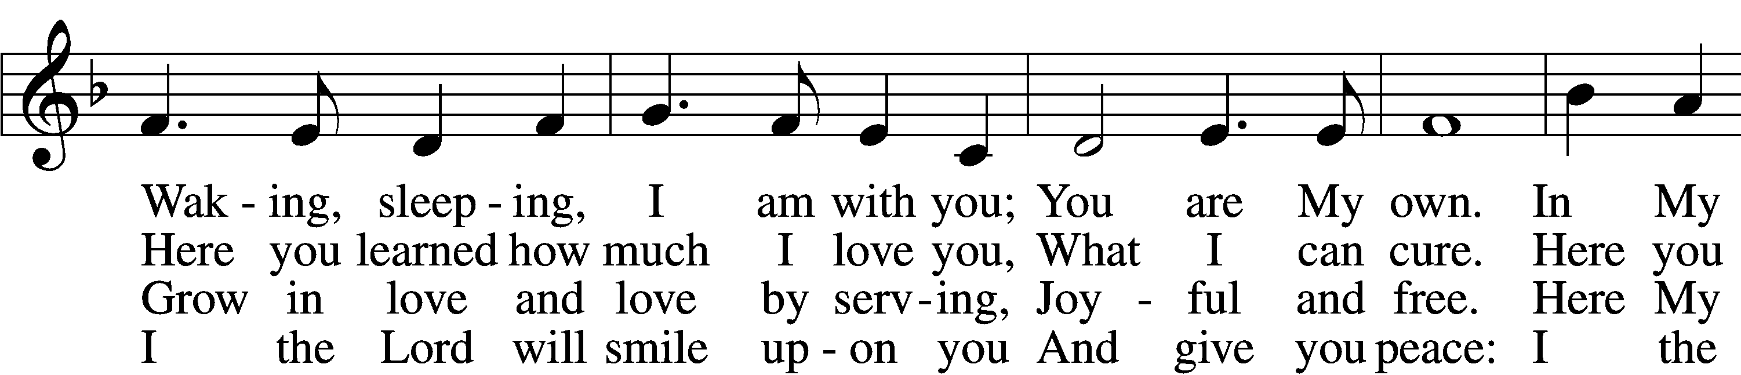
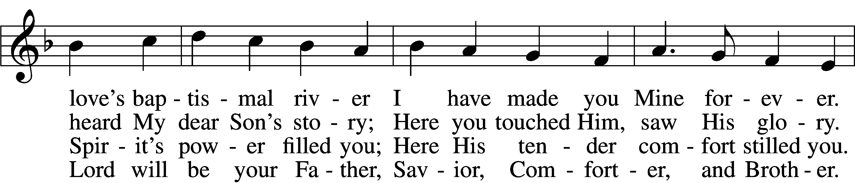
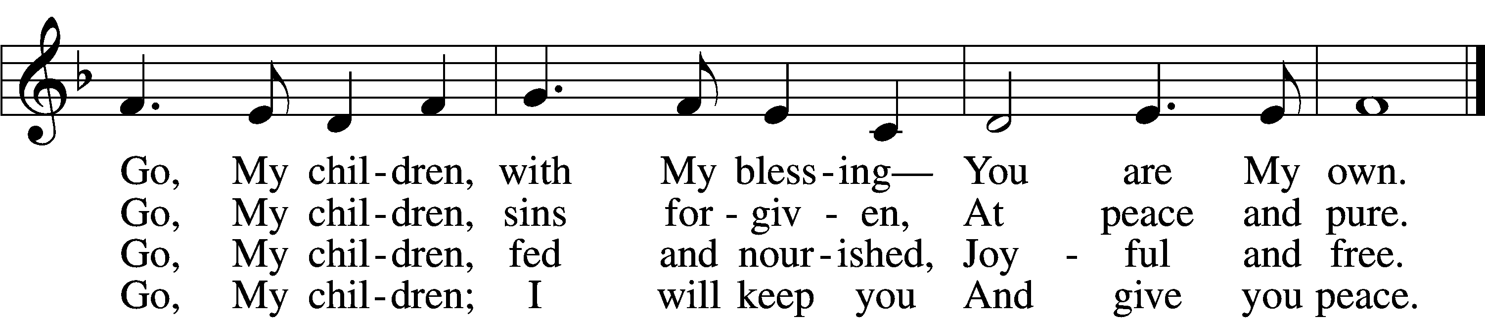
ANNOUNCEMENTS and SENDING WORDS
P We go to live for Jesus!
C We go to share His love!

Acknowledgments
Unless otherwise indicated, Scripture quotations are from the ESV® Bible (The Holy Bible, English Standard Version®), copyright 2001 by Crossway, a publishing ministry of Good News Publishers. Used by permission. All rights reserved. Created by Lutheran Service Builder. Music reproduced in this service is used with permission through: CCLI License No.1776588 and CPH – LSB Service Builder.

SERVING IN GOD’S HOUSE TODAY
Pastor: Rev. Ken Bernthal
Elder: Glenn Smith
Ushers: John & Judi Stutzman
Greeters: Risa Sherman, Leslie Martin
Children’s Talk: Nancy Ely
Altar Care: Nancy Ely
Piano/ Organ: Tom & Jean Beach
Counters: Donna Cottrell, Laverne Scheiterlein
Coffee Servers: Paul & Karen Schneider
Sunday School; Sharon Techel, Jean Beach
Sunday Morning Bible Study: w/ Dr. Tom Beach

PRAYERS
Please contact the office with updates to the prayer list. People will remain on the prayer list for 4 weeks before being removed. If they need to remain on the list, please keep Elaine informed and of any updates. This will help us to have a more accurate list. Thanks for your cooperation.
Those who continue to grieve the passing of loved ones, The Family of Hilda Koch.
Those with upcoming surgery:
Those recovering from surgery: Joann Whitney, Jim (Joann Whitneys brother in law), Rev. Paul Schneider, and Roxy Mohr.
Those with health concerns: Tiffany Amsdill, Ruth Bennett (Sharron Kato’s Sister), Tanner Beyers, Hope Buchinger, Betsy Cook, Kay Gregg, Paul Kietzman, Jennifer Martin, Eleanor Raether, Beth Smith, and Judi Stutzman.
Those diagnosed with cancer: Sue Cavanagh (diagnosed with breast cancer). Leah Eicher, Rachel Frisch, Janice Knoellinger, Leslie Martin, Brian Morgan, and Hope Osantowski.
Those under Hospice Home Care: Ken Williamson, Jim (Joann Whitney’s brother-in law).
Prayers of Thanksgiving for the birth of Carla and John Elenz new granddaughter, Lydia Helen born to Todd and Victoria Elenz.

BIRTHDAYS: ANNIVERSARIY
10/09 Mike Goodrich 10/12 Renne & Lynette Girard
10/09 Julie Hull
11/10 Pam Beasinger
10/13 Jack Osantowdki

MESSAGES
ALTAR FLOWERS ALTAR FLOWERS today is given to the glory of God by Nancy Ely in Celebration of Caroline’s Birthday.
MEMBER & GUEST CARDS: If you have not filled out a member/guest card, please take the time to fill one out and place it in the plate behind the back pews in our sanctuary.
GREETING CARDS If you are in need of some greeting cards, we carry an array of them. The card cabinet is in the hallway across from the library. The cost of the cards is posted on the cabinet. The money collected from the cards goes to LWML to help support Missions.
CHURCH EXTENSION FUND has proven investment products with measurable results. Since 1901, through dedicated Christian financial management, CEF is focused on funding the needs of Michigan District congregations. (Proven, Dedicated, Focused)
For more information, contact (Congregation Representative and telephone number) or call 800-242-3944.
WEDNESDAY MORNING BIBLE STUDY 10:00am w/ Rev Ken Bernthal (Fellowship Hall.)
LARGE PRINT WORSHIP FOLDERS: We now have large print worship folders they are on the table in the back of the sanctuary with the offerings. Please fill free to take on.
CANCER & FRIENDS SUPPORT GROUP: Contact Elaine for more information 989-350-4391 call or text.
SUNDAY MORNING BIBLE STUDY 10:30 am with Dr. Tom Beach.
PORTALS OF PRAYER: For October- December are the shelf in the narthex, please feel free to take one.
KUT-UPS: the dates for this year are as follows:
Oct. 10 and 24 Nov. 7 and 21 Dec. 5 and 19
KUT-UPS: Blessing of the Quilts today.
TRUNK OR TREAT: Monday October 31 in the church parking lot, if it rains it will be held in the Church. We are also in need of some candy to hand out to the children if you can donate any please put it in the box under the shelf in the Narthex. If you would like to join us, please do, all you have to do is decorate your trunk, wear a costume or not and pass out candy from the trunk of your car.
CRAFT ACTIVIES; On Saturday October 15th we will be doing another craft day, we will be making Christmas Cards sign up sheet and information are posted on the board in the narthex or contact Jennifer Martin at 989-370-4447 or Laurie Breen 989-939-7432. This is always a fun activity.
LWML OCTOBER MEETING will be on Tuesday, October 18th. It will begin with a 5pm soup supper, followed by a brief business meeting, then a time to create a Thanksgiving devotional booklet/journal, which you can take home. The journal will be a daily reminder of God’s blessings, for your use during the month of November. All the supplies for making your booklet will be ready and waiting for you that evening. Remember, all women of Trinity are part of LWML (Lutheran Women’s Missionary League), and all are encouraged to attend. We moved up the time of the meeting to 5pm and are including the soup supper, in hopes of making LWML activities easier to attend.

SERVING IN GOD’S HOUSE NEXT SUNDAY 10/16/2022
Pastor: Rev. Paul Schneider
Elder: Tom Raithel
Ushers: Bill & Terry Stiles
Greeters: Beyers Family
Counters: Wendell Smith, Karl Scheiterlein
Coffee Servers: Bob & Kathy Erat
Altar Care: Linda West
Virtual Organ: Bob Erat
Children’s Talk: Nancy Ely
Children’s Sunday School: Sharon Techel, Jean Beach and Nancy Ely
Sunday Morning Bible Study: w/ Dr. Tom Beach 10:30am

THIS WEEK AT TRINITY
October 9 Sunday
9:00 am Worship Service. -Rev. Ken Bernthal
Baptism of Jeffery Trahin & Blessing of the Quilts.
10:00 am Fellowship & Coffee Hour
10:00 am Children’s Sunday School-after the church service
10:30 am Sunday Morning Bible Study W/ Dr. Tom Beach
October 10 Monday
10:00 am Kut-Ups
7:00 pm Choir
October 11 Tuesday
6:30 pm Church Council Meeting (Fellowship Hall)
October 12 Wednesday
10:00 am Wednesday Morning Bible Study w/ Rev. Ken Bernthal
October 13 Thursday
1:00 pm Ladies Guild Meeting (Library)
October 14 Friday
October 15 Saturday
12:00 pm Craft Activitie Christmas cards. (Fellowship Hall)
October 16 Sunday
9:00 am Worship Service – Rev. Paul Scheneider
10:00 am Fellowship & Coffee Hour
10:00 am Sunday School after the church service
10:30 am Bible Study with Dr. Tom Beach (Sunday School Room)

